Elea Durant
Candidate Number: 8579
Centre Number: 16525

Short Film Evaluation

Narrative Structure

In my short film, I wanted to create a concise yet impactful story that relies on enigma, tension and a clear narrative arc. I chose ‘a narrative which has a distinct genre’ from the brief.
My short film follows a traditional structure, using enigma as a key element to create suspense and engage the spectator. The opening act introduces the protagonist as she lies in bed, bored and relentless. She wants a change of scenery, so she decides to go on a walk to her nearby village park, unaware that this simple decision will lead to her demise. Upon arriving, she encounters her doppelganger, an eerie and dangerous reflection of herself. This immediately establishes a sense of unease and raises questions that draw the audience in – who or what is this figure, and why does it look exactly like her? The film also employs diegetic elements, such as the protagonist’s text messages to her boyfriend, to provide insight into her psychological state. These interactions add a secondary layer of tension, as he subtly gaslights her, making her question her own perception of reality. The film employs a creative use of mise-en-scene; a motif of the colour red which foreshadows our protagonist’s execution.
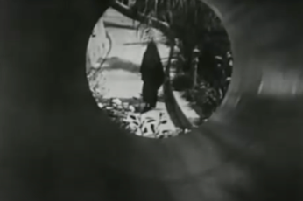
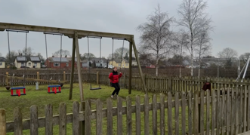
I took inspiration from my analysis of Meshes of the Afternoon (Deren, US, 1946), which also explores psychological horror and themes of identity. Like in Deren’s film, my protagonist encounters a doppelganger-like figure that blurs the lines between reality and illusion. The surreal and unsettling atmosphere in Meshes of the Afternoon influenced my approach to pacing, cinematography, and repetition, helping to create a sense of inevitability and dread. Additionally, I was inspired by the film’s use of a long shot to introduce the eerie figure, establishing its ominous presence within the frame – just as I do in my film to heighten unease and suspense.
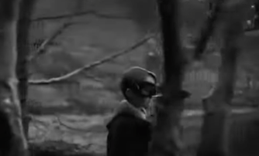
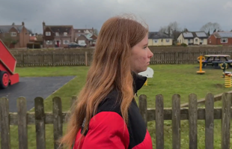
Lynne Ramsay’s The Swimmer serves as a key inspiration for my short fiolm, paritcularly in its striking editing techniques that contribute to an eerie, dreamlike atmosphere. Ramsay’s film employs abdupt, jarring cuts between seemingly disconnected images, creating a sense of unease and disorientation. This technique can be used in my film to emphasise the doppelganger’s constant, lurking presence, making it feel inescapable. In The Swimmer, Ramsay intercuts between dark silhouettes, omnious lanscapes, and fleeting glimpses of figures, often without clear context, forcing the audience to piece together meaning. I apply a similar approach by cutting between the proragonist and her doppelganger in unexpeceted ways – for example, in the chase scenes where it cuts from her to the doppelganger, when she appears in the window and standing in the cabin. These rapid, unsettling edits create a feeling of psychologucal instability, as if the protagonist’s world is subtly unraveling. As the film progresses into the middle act, this disjointed editing style heightens the suspense. The doppelganger’s presence becomes more aggressive and intrustice, shifting from distant, eerie glimpses to direct confrontations. By manipulating time and space through editing, the film reinforces the idea that the doppelganger isn’t just physically pursuing the protagonist – it’s warping reality around her. The sound design further enshances this effect. In The Swimmer, Ramsay often overlays audio from one scene onto another, creating an uncanny, echo-like effect. In my film, this is used to make the doppelganger’s presence feel even more oppressive – for instance, the music playing over her chasing the protagonist. By adopting Ramsay’s fragmented, rhythmic editing style, I can create a film where the doppelganger feels both tangible and unreal, leaving the audience questioning its true nature. The result is an esculating sense of dread, as the protagonist and the audience begin to realise that escape may not be possible.

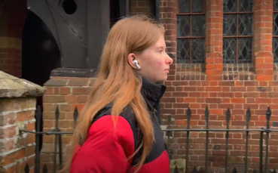
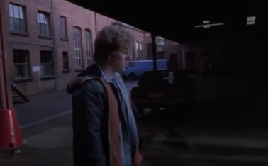
I also drew inspiration from Alan Clarke’s ‘Elephant’. Long tracking shots are used to create a sense of inevitability. Clarke’s use of long, unbroken tracking shots creates an overwhelming sense of inevitability, as if events are unfolding in a cold, detached manner that the characters and the audience cannot escape. This technique mirrors the way the protagonist in my film gradually realises the presence of the doppelganger, making its emergency feel disturbingly natural, yet inescapable. Additionally, Clarke’s approach to unexplained violence adds to the unsettling atmosphere. In Elephant, assignations happen suddenly and without clear motive, leaving the audience in a state of shock. This section relies on the classic horror techniques, such as pacing, sound design, and cinematography, to build dread. The enigma deepens as the audience is left uncertain about the nature of the doppelganger – is it supernatural, a hallucination, or something entirely different? The protagonist’s fear grows which contrasts with her boyfriend’s dismissive messages, reinforcing the themes of isolation and manipulation.
Overall, the narrative structure balances mystery, suspense, and psychological horror. The enigma keeps the audience interested, while the text messages between the protagonist and her boyfriend add a modern and unsettling psychological aspect. By intertwining external horror with internal doubt, the film creates an experience that plays on both supernatural and psychological fears.

Influences, meaning and effect:
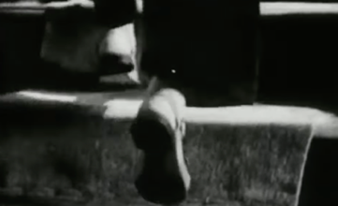
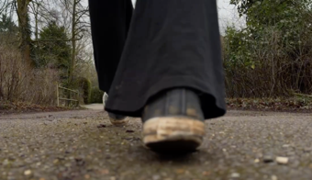
To further enhance the unsettling atmosphere, I also drew inspiration from David Lynch’s ‘The Grandmother’ in my use of music. Lynch’s short film uses unsettling imagery, nightmarish sound design and dreamlike storytelling to evoke a deep sense of dread and isolation. Lynch is known for his experimental use of sound – low, droning noises and echoing whispers. Abrupt, jarring transitions from total silence to disturbing sounds which heightens the horror. The film’s eerie and hypnotic soundtrack adds to its dreamlike quality, which led me to include an old, nostalgic song in my short film; ‘We Belong Together’ by Ritchie Valens. The contrast between the familiar, almost comforting melody and the horror unfolding on screen creates an uncanny effect, deepening the sense of disorientation and dread. The protagonist initially puts this song on through her headphones as she walks to the park, making it a diegetic element that reflects her initial calm and detachment. However, as the film progresses, the same song returns in a non-diegetic form, playing over the frantic running scenes and her death scene. This repetition creates an eerie cyclical effect, reinforcing the inevitability of her fate and adding an unsettling layer of irony to her death. The shift from diegetic to non-diegetic sound alters the spectator’s perception of the music – from something ordinary to something deeply ominous, further heightening the horror. The music that follows her death is also a form of closure, making the end of her struggle and the end of her story. It contrasts sharply with the frantic, chaotic energy of the girl’s running, highlighting how her death represents an inevitable and inescapable conclusion to the battle within herself. There’s no release, no redemption – just an eerie, melancholy reflection on the futility of her attempts to flee from what she has become. The inclusion of the non-diegetic music also speaks to the existential theme of the film. It’s almost as if the music is commenting on the cyclical nature of self-doubt and internal conflict – how we are often haunted by our own fears and darker desires, and how we may never fully escape from them, no matter how desperately we try.

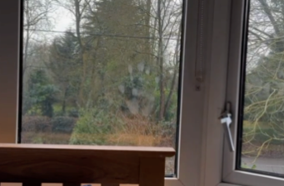
The handprint on the window initially seems unremarkable, blending into the girl's ordinary environment. However, it subtly builds tension, hinting at an unseen presence. As it lingers in the frame, its significance grows, foreshadowing the arrival of the girl’s evil doppelgänger. When the double finally appears, she presses her hand against the same window, mirroring the original print. This chilling parallel reinforces their connection, making the window a symbolic boundary between the girl’s two identities.

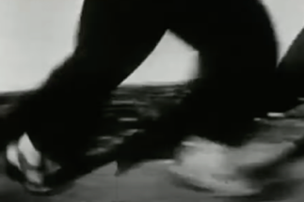
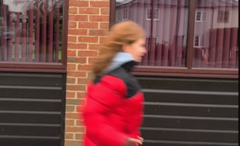
Another element which creates meaning and effect is the intercutting between the girl and her doppelganger running in the film. This serves as a powerful visual tool that not only contrasts their physical movements but also underscores the conflict at the heart of the story. The juxtaposition of camera techniques – shaky handheld shots for the normal girl and smooth, steady shots for the doppelganger – creates a sense of tension and underscores the psychological and emotional difference between the two characters.
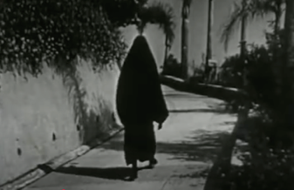
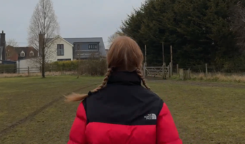
When the ‘normal girl’ is running, the camera follows her with shaky, handheld movements. This unsteady, erratic style of cinematography mirrors her inner turmoil, confusion and vulnerability. The unstable camera reflects her frantic state as she attempts to escape or confront something she cannot fully comprehend, capturing her disorientated perspective. The viewer feels her anxiety, almost as if we are experiencing her struggle first-hand, immersed in her unstable world. In stark contrast, the ‘evil doppelganger’ is shown running with a steady, controlled camera movement. This choice of a smooth, almost gliding camera suggests a sense of dominance, calm, and purpose. The doppelganger is in control, seemingly at ease with her environment, her movements are deliberate and calculated, unlike the girl’s frantic escape. The smoothness of the shots creates a sense of predestination, as though the doppelganger is in control of the situation and inevitably closing in on the girl.

As the girl reaches the safety of her house, there’s a moment of fleeting hope, but it quickly turns into a devasting realisation. When she turns around, the absence of the doppelganger is initially relieving – she doesn’t see the evil version of herself chasing her anymore. However, this momentary reprieve is short-lived as her gaze shifts upward, and she sees the doppelganger standing in her bedroom window with her hand pressed against the same spot where the handprint was visible earlier in the film.
This return to the handprint creates a haunting sense of inevitability. The handprint on the window, which was a subtly but significant detail early in the film, is now visually reconnected with the doppelganger, making it clear that the darker self has been present all along, just outside of the girl’s awareness. The hand on the window serves as a powerful symbol of possession – her doppelganger’s control over her life, her body, and ultimately, her fate. The doppelganger’s wave and smile are an unsettling display of control – her clam demeanour juxtaposed against the girl’s frantic terror, a reminder that the girl is not just being chased’ she is being drawn into her own destruction, as the doppelganger has already claimed her place in the house, in the girl’s own world.
The girl’s immediate, panicked response – running frantically around the side of the house and toward the cabin – illustrates her desperation and a final, futile attempt to escape. The fact she runs to the cabin, a more isolated and presumably secure place, symbolises her attempt to retreat into a place of safety, but this sense of safety is fleeting. Her panic has led her nowhere.

Word count: 1780

